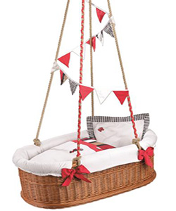

Universal swing

$28.78

Avilability: In stock

**Description:**

Cute brown hanging basket like swing for baby. The swing comes with an adjustable fabric canopy that provides UV and sunlight protection so that you and family stay cool and comfortable. You will enjoy this stylish swing as it crafted for long-lasting durability. It is a great start for transforming your garden into a secret getaway. It will stand out in your outdoor living space with its inviting design.